**Introduction**

**Data and Methods**

The data on weekly spending on tobacco products comes from the Smoking Toolkit Study (STS) (Fidler, et al., 2011), a cross sectional study in which a sample representative of the English population is collected monthly. We use the data collected between April 2014 and February 2020. These dates are chosen to cover the full period in between local authority identifiers first being available in the data and the start of the Covid-19 pandemic in the UK. This range provides an adequate sample size for calculations at local authority level. The spending figures are adjusted to December 2018 prices using the consumer price index (CPI) for tobacco products. Figure 1 presents the distribution of all inflation-adjusted weekly expenditures in the data, which yields a self-reported median spend of £20.28 and mean spend of £25.57 per smoker per week for England as a whole. The distribution is positively skewed with several outliers.

Income data are obtained from the ONS at middle layer super output area (MSOA) level for the financial year ending March 2018. These data are aggregated to upper tier local authority level, by taking the population-weighted average. These figures can be matched to local authority level spending calculated from the STS data to estimate average tobacco spending as a proportion of income by local authority. The income figure used throughout is net equivalised household income after housing costs. The data on smoking prevalence and the number of smokers by local authority, used in combination with average weekly spending calculated from the STS to obtain population total spending estimates, are obtained from the Public Health England local tobacco control profiles for 2019 (Public Health England, 2020).

The estimated total annual expenditure based on the mean self-reported weekly expenditure on tobacco, and an estimated 6.131 million smokers in England, is £7.59 billion per year. This figure is below the total collected by the government in tobacco duty alone, receipts of which totalled £8.84 billion in the calendar year 2018 and £8.75 billion of which came from cigarettes and hand-rolling tobacco (HRT). To estimate the duty receipts specifically from spending by English smokers, we adjust the total duty receipts for the UK by the percentage of UK smokers who are English (calculated from the Annual Population Survey and estimated at approximately 82.25%). When making the England-only adjustment, total tobacco duty receipts from England are still estimated at £7.64 billion. This suggests the mean weekly expenditure figure of £23.81 is an under-estimate of the true mean due to under-reporting in the data. In order to produce mean weekly spending estimates from the toolkit data which are consistent with the amount implied by HMRC duty receipts, we therefore estimate an upshift factor to apply to the spending data.

To calculate the required upshift factor we estimate the total annual expenditure implied by the total duties received by HMRC and take the ratio of this figure to the estimate based on the raw toolkit data. We do this separately for factory-made cigarettes and hand-rolling tobacco (HRT). The approach for each product is to take the price (per pack of 20 cigarettes or per 100g of HRT) and calculate the total duty paid on the respective quantity – based on the duty rates on December 2018. The percentage of the market price which is paid as duty is calculated from these figures and applied to the duty receipts data to estimate total expenditure on (legally supplied) tobacco. Price data for cigarettes is obtained from the ONS and the December 2018 price of £10.63 for a pack of 20 cigarettes is used in the calculation. For HRT, price is taken as an average of online supermarket prices in December 2020 and deflated to December 2018 prices using the All-Tobacco component of the consumer prices index (CPI).

As some consumption of tobacco products is from illicit sources, we also estimate expenditure on illicit tobacco. HMRC estimate the “tax gap” which arises from the market for illicit tobacco. Using estimates from the 2016/17 tax year of the market shares of illicit and legal tobacco sources of total consumption by product, expenditures on illicit sources of consumption are calculated as the legal expenditure multiplied by the illicit market share as a proportion of the legal market share. For factory-made cigarettes this ratio is 0.15/0.81 = 0.185 and the equivalent for hand-rolled tobacco is 0.28/0.67 = 0.418. Note the remaining market share in each case relates to cross-border sourced tobacco and is excluded from the calculations of total spending.As the market shares are shares in consumption not expenditure, and prices per cigarette are lower for illicit sources, this figure is multiplied by the average illicit price as a proportion of the average legal price. The average cost of illicit sources of tobacco are approximately half of the average legal price for both factory-made cigarettes and hand-rolling tobacco (ASH Scotland, 2021).

Based on the above calculations, we multiply the survey responses by a factor of around 1.93 to account for underreporting of spend. The detailed breakdown of the upshift factor calculation is given in Table 1.

Table 2 presents the impact of this upshifting on average weekly expenditure on tobacco, estimated for different population subgroups in the STS data. Average spending is slightly higher for those on lower social grades (£46.71 in C2DE compared to £44.70 in ABC1) and is similar for male and female smokers. The starkest differences are by age and by region. The oldest (aged over 45) smokers spend around £50 per week on tobacco while the 16-24 age groups spend around £35 per week. Regional variation is also substantial, ranging from an average weekly spend per smoker of £39.37 in the Southwest compared to £54.12 in the Northeast.

The smoke free dividend is the portion of spending on tobacco, which is not directly benefiting the local economy, due to being transferred to the treasury as tax revenue, manufacturers, or to criminals through the illicit trade. Of total retail sales of tobacco an estimated 7% is profit margin to the retailer (ASH, 2016). Of total annual expenditure on tobacco products from legal suppliers we therefore calculate 93% of that spending is smoke free dividend. We attribute all expenditure on illicit tobacco as smoke free dividend. The aggregate estimate of the share of illicit tobacco out of total tobacco expenditure, across cigarettes and HRT, is approximately 10%. We apply this percentage to each local area in our calculations to divide spending into legal and illicit.

**Results**

Table 3 presents estimates of the annual smoke free dividend by region. In total we estimate that the approximately 6.1 million smokers spend a total of £14.652bn on tobacco products, of which £13.731bn is the potential dividend to making smoking completely obsolete. There are clear regional differences in the average expenditure of smokers on tobacco, ranging from around £54 per smoker per week in the Northeast to just over £39 in the Southwest. This differential of £15 per week between the highest-spending and lowest-spending regions amounts to a non-negligible £780 difference over a year.

This variation in average spending by region suggests the presence of geographical inequalities in the financial burden of smoking, and this is demonstrated by differences in the proportion of average income by region that the spending figures represent. In London, the Southeast and Southwest, the proportion of disposable income spent on tobacco is under 8%, between 8% and 9% in the East of England and East Midlands, and larger still in the Northeast, Northwest, Yorkshire and the Humber, and in the West Midlands. The spending proportion is particularly high in the Northeast – the region with the highest average spending per smoker - where tobacco spending is over 11% of disposable income.

As a region level analysis can mask considerable variation in local authorities within regions, we also produce calculations at the upper tier local authority (UTLA) level. Of the 151 UTLAs, 10 had fewer than 10 observations in the pooled STS 2014-2020 data and so we exclude these from the analysis. Differences in the financial burden of tobacco between regions can arise due to differences in spending and differences in incomes. When comparing spending and income at the local authority level, Figure 2 illustrates a very slight negative correlation between spending and disposable income, showing that in the more deprived areas of the country that smokers spend more money on tobacco products – or at least spend no less than in the wealthier local authorities. This weakly negative correlation between weekly spending on tobacco and disposable income suggests a clear social gradient in the financial burden of smoking, with poorer smokers spending similar amounts of money on tobacco to wealthier smokers and consequently dedicating a larger proportion of their disposable income to tobacco consumption.

The impact of smoking on the most deprived becomes does indeed become even more stark when spend on smoking is expressed as a percentage of income. Figure 3 plots annual average income and the percentage of a smoker’s net disposable income (after tax and housing costs) spent on tobacco products. There is a much clearer negative correlation between the average income of a local area and the average proportion of income which is spent on tobacco products by smokers in the local area.

While levels of spending are only weakly – if at all – correlated with income, the amount of consumption is not. As illustrated in Figure 4, there are higher levels of self-reported tobacco consumption by smokers in poorer local authorities. This may be due to differences in the types of tobacco product consumed across local authorities with differing levels of income. We find no evidence, however, that the proportion of smokers consuming HRT differs by local authority average income, and average consumption of both factory-made and HRT cigarettes is higher in lower income areas. One possible explanation for the greater variation in consumption by levels of income relative to differences in spending is that there is geographic variation in the prices of similar products, with lower income areas also experiencing lower prices.

Tobacco consumption is higher among smokers from the poorer areas of England relative to wealthier areas. This, combined with average spending figures which are roughly similar across local authorities of differing average incomes, means that a greater amount of disposable income is spent on tobacco in poorer areas than by smokers in richer areas, leading to a greater financial burden. Along with the health risks of smoking, the higher smoking prevalence and tobacco consumption in lower-income areas combined with the financial burden means there are significant inequalities, both health and economic, that can be alleviated by making smoking obsolete.

Figure 5 shows the geographic inequalities in income and the financial burden of tobacco, plotting deciles of both average income on the map in the left panel and the proportion of average income spent on tobacco in the right panel. In both cases a lighter shade represents a higher decile. The figure illustrates the geographical location of the higher and lower-income local authorities, the former being primarily located in the south of the country and the latter in the Northeast and Northwest. There is a clear contrast with the geographic dispersion of higher and lower spending proportion local authorities. The UTLAs in the lowest deciles for tobacco spending as a proportion of income are generally in the Southeast, Southwest, and East of England.

**Discussion**

# **References**

ASH. (2016). *Counter Arguments - How important is tobacco to small retailers?* Retrieved from Action on Smoking and Health: https://ash.org.uk/information-and-resources/reports-submissions/reports/counter-arguments-how-important-is-tobacco-to-small-retailers/

ASH Scotland. (2021). *Calculating the cost of smoking.* Retrieved from https://www.ashscotland.org.uk/media/850413/28-calculating-the-cost-of-smoking-june-2021.pdf

Fidler, J., Shahab, L., West, O., Jarvis, M., McEwan, A., Stapleton, J., . . . West, R. (2011). The smoking toolkit study: a national study of smoking and smoking cessation in England. *BMC Public Health*, 11 (1-9).

Public Health England. (2020). *Local Tobacco Control Profiles*. Retrieved from https://fingertips.phe.org.uk/profile/tobacco-control

**Table 1) Calculation of the upshift factor.**

|  |  |  |  |  |  |  |
| --- | --- | --- | --- | --- | --- | --- |
| HMRC Stats | | | | | | |
| Cigarettes | | | Hand-Rolled | | | Totals (£m) |
| (1) Total duty receipts (£m) |  | 6,372 | (1) Total duty receipts (£m) |  | 1,188 |  |
| (2) Pack Price (£ per 20 cigs) |  | 10.63 | (2) Price per 100g (Dec 2020) |  | 51.60 |  |
| (3) Ad-Valorem tax rate |  | 0.165 | (3) Price deflator |  | 0.93 |  |
| (4) Ad-Valorem tax (£ per pack) | (2) * (3) | 1.75 | (4) Price per 100g (Dec 2018) | (2) * (3) | 47.90 |  |
| (5) Specific duty (£ per 1000 cigs) |  | 228.29 | (5) Specific duty (£ per kg) |  | 234.65 |  |
| (6) Specific duty (£ per pack) | (5) / 20 | 4.57 | (6) Specific duty (£ per 100g) | (5) / 10 | 23.46 |  |
| (7) Total excise (£ per pack) | (4) + (6) | 6.32 |  |  |  |  |
| (8) Total excise % of price | (7) / (2) | 59.45% | (8) Total excise % of price | (6) / (4) | 48.98% |  |
| (9) Total legal cigarette spend (£m) | (1) / (8) | 10719 | (9) Total legal HRT spend (£m) | (1) / (8) | 2425 |  |
| (10) Total illicit cigarette spend (£m) |  | 994 | (10) Total illicit HRT spend (£m) |  | 507 |  |
|  |  |  |  |  |  | 14,645 |
| Survey data estimate | | | | | | |
| Total grossed-up expenditure |  |  |  |  |  | 7,591 |
| Dataset : | Toolkit |  |  |  |  |  |
|  |  |  |  |  |  |  |
| Upshift Factor: | 1.929 |  |  |  |  |  |

**Table 2) Mean Weekly Spending on Tobacco**

|  |  |  |  |
| --- | --- | --- | --- |
| Group | | Not Upshifted (£) | Upshifted* (£) |
| All |  | £23.81 | £45.94 |
| Social Grade | ABC1 | £23.17 | £44.70 |
|  | C2DE | £24.21 | £46.71 |
| Sex | Male | £23.88 | £46.07 |
|  | Female | £23.74 | £45.79 |
| Age group | 16-24 | £18.39 | £35.47 |
|  | 25-34 | £22.94 | £44.26 |
|  | 34-44 | £24.98 | £48.20 |
|  | 45-54 | £26.15 | £50.44 |
|  | 55-64 | £26.48 | £51.09 |
|  | 65+ | £25.65 | £49.49 |
| Region | East Midlands | £24.51 | £47.29 |
|  | East of England | £24.10 | £46.49 |
|  | London | £23.48 | £45.29 |
|  | North East | £28.05 | £54.12 |
|  | North West | £24.11 | £46.50 |
|  | South East | £23.06 | £44.49 |
|  | South West | £20.41 | £39.37 |
|  | West Midlands | £24.73 | £47.71 |
|  | Yorkshire and the Humber | £24.33 | £46.93 |

*\*Upshift factor of 1.929 applied to raw spending data*

**Table 3) Smoke free dividend estimates by region**

|  |  |  |  |  |  |
| --- | --- | --- | --- | --- | --- |
| Region | Spend per smoker (£) | Number of Smokers | Total Annual Spend (£m) | % of Income on Tobacco | Dividend (£m) |
| East Midlands | £47.29 | 566,850 | £1,394 | 8.69% | £1,306 |
| East of England | £46.49 | 669,833 | £1,619 | 8.07% | £1,518 |
| London | £45.29 | 896,639 | £2,112 | 7.47% | £1,979 |
| North East | £54.12 | 326,442 | £919 | 11.35% | £861 |
| North West | £46.50 | 837,814 | £2,026 | 9.58% | £1,899 |
| South East | £44.49 | 873,863 | £2,021 | 7.37% | £1,894 |
| South West | £39.37 | 631,799 | £1,294 | 7.40% | £1,212 |
| West Midlands | £47.71 | 650,297 | £1,613 | 9.65% | £1,512 |
| Yorkshire and the Humber | £46.93 | 677,670 | £1,654 | 9.40% | £1,550 |
|  |  |  |  |  |  |
|  |  | 6,131,207 | £14,652 |  | £13,731 |

**Figure 1) Distribution of Weekly Spending on Tobacco**

**Figure 2) Local Authority Average Weekly Spending**

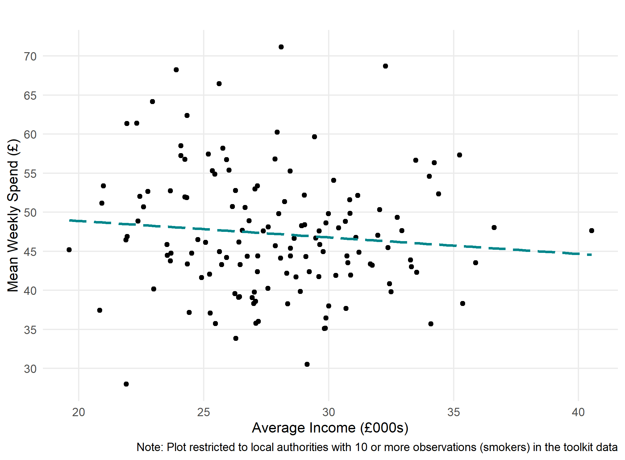

**Figure 3) Local Authority Average Weekly Spending as a Proportion of Income**

**Figure 4) Local Authority Average Daily Cigarette Consumption**

**Figure 5) Deciles of Income and Spending as a Proportion of Income by Local Authority**

**Extra Figures/Tables**

**Distribution of Weekly Spending by Region**

**Percent of smokers who consume HRT and average income**

